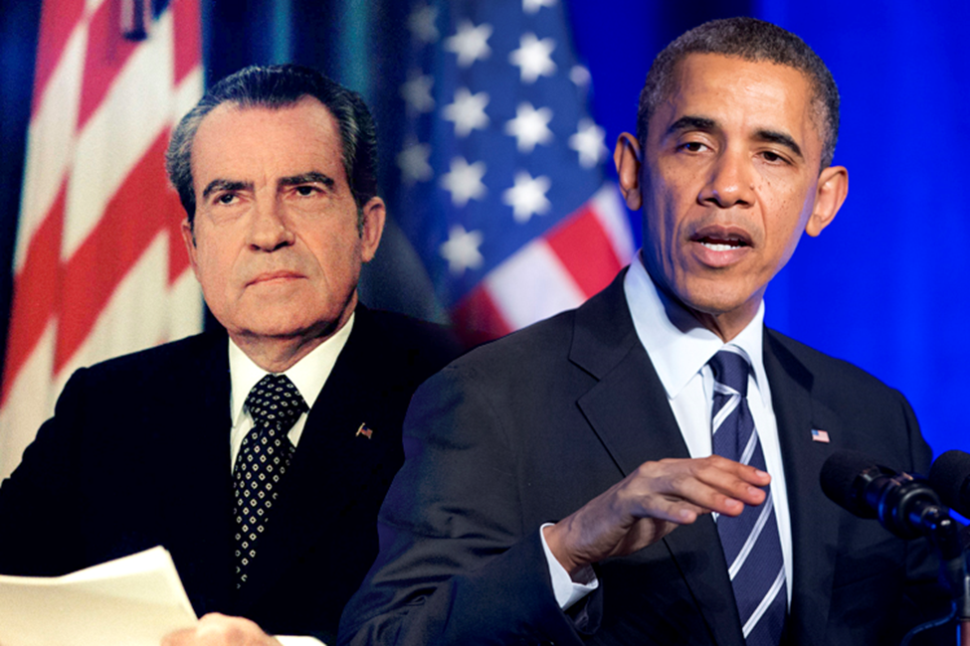
Norris C. Land
Professor Humphress
PAD510
July 16, 2015

Introduction
This writing will talk about President Nixon and President Obama’s healthcare policies. It will address the historical perspective of these policies, the social, economic, and political environments during these policies, and critiques of the policies for their effectiveness during the time they were discussed or implemented.
Historical perspective
In 1971, Republican President Richard Nixon proposed arguably one of the most liberal health care plans America had ever heard of to ensure quality insurance. As opposed to Democratic President Barack Obama, Nixon exceeded the reaches of a radical liberal. It should be noted that these are two of the most controversial health care policies in history. Those who are familiar with the historical aspect of America’s health care laws, would not have been surprised when Mr. Obama presented his administration's health care plan in 2010 because it was almost the same as Nixon's. In 1972 Nixon penned a message to Congress on health care in which he defended his motives and elaborated on the importance of certain policies. The ultimate goal was/is to reduce the number of people who lack health insurance coverage, and both Nixon’s plan and Obama’s ACA were designed to provide coverage to the uninsured American population while keeping health care costs at a minimum. When Nixon proposed the health care plan in 71’, it was viewed as a radical liberal approach and was met with vehement opposition from the opposing party. Nixon’s plan was extreme compared to Obama’s Affordable Care Act and was shut down. However, in 1974 Nixon proposed a revision to the afore mentioned plan, But that plan failed to pass as well. The key elements in Nixon’s proposed policy were: All employers are required to provide basic health care insurance, including an array of specific coverage requirements, employees are required to share the cost of insurance up to a cap, insurance companies can only vary benefit packages to an extent, special insurance programs at reasonable rates for self-employed and others, replace most of Medicaid for poor families with a completely federal plan that's open to any family below a certain income level, and cost-sharing rises because of income, people who made more share a larger portion of the financial cost. President Nixon then followed this up with a Comprehensive Health Insurance Plan in 1974 which entailed: All employers must insure all full-time employees with employee cost-sharing up to a cap and federal subsidies to aid employers, and those who can’t afford health care coverage or are not eligible for employee health care insurance or Medicare, can choose to enroll in an open plan with Medicaid. (Samantha Olson, 2015) President Obama's Affordable Care Act of 2010 stated: Business owners (with more than 50 employees) must offer affordable insurance with a minimum set of benefits to a majority of employees, or pay more if their employees qualify for a tax credit to buy insurance on a marketplace instead, small business owners can buy insurance through a special program, the smallest employers can get a tax credit, (affordable coverage is defined as health insurance that costs less than 9.5 percent of household income) Medicaid expanded by offering states funding to cover individuals earning up to 133 percent of poverty level (fully, at first, and then weaning down to 90 percent over time), provides minimum package of insurance benefits for all newly eligible individuals, and providers are paid equal rates for caring for Medicaid and Medicare patients. (Olson, 2015)
In 1970, the economy continued to grow but inflation was becoming a serious problem and rising health care costs were becoming of major interest. In 1971, President Nixon initiated wage and price freezes in an effort to curtail the growing inflation. With the enactment of Medicare and Medicaid, health care costs had ballooned from 4 percent of the federal budget in 1965 to 11 % by 1973, and consequently millions under the age 65 still had no health coverage. Under the wage and cost controls, medical care was singled out for specific limits on annual increases in physician and hospital fees. These were eliminated in 1974, more than a year after most other economic controls had ended. An era of health care regulation began, leading to certificate-of need programs, state hospital rate-setting, requirements on HMOs (in return for support to help them expand) and health planning to control growth. In 1974 Nixon followed this up with his Comprehensive Health Insurance Plan (CHIP) which called for universal coverage, voluntary employer participation, and a separate program for the working poor and the unemployed, replacing Medicaid. This required employers to contribute 65% of the premium cost was controversial, but essential to the plan’s financing. Concerning the urgency for reform, on June 2, 2009, President Obama met with some key Senators on health reform and stated, “… health care reform is not a luxury. It's a necessity we cannot defer. Soaring health care costs make our current course unsustainable. It is unsustainable for our families, whose spiraling premiums and out-of-pocket expenses are pushing them into bankruptcy and forcing them to go without the checkups and prescriptions they need. It is unsustainable for businesses, forcing more and more of them to choose between keeping their doors open or covering their workers. And the ever-increasing cost of Medicare and Medicaid are among the main drivers of enormous budget deficits that are threatening our economic future.” (President Obama, June 2, 2009 to Senators Ted Kennedy and Max Baucus)
The social, economic, and political environments
The twentieth century was unkind to would-be health care reformers like President Nixon. National health insurance proved a maddeningly elusive goal to Nixon, who tried and failed to overhaul the nation’s health care system. He ran into an array of formidable hurdles, which included intense resistance from stakeholders such as the American Medical Association, business, and the insurance industry; fragmented political institutions that made passing health care bills, even where the president’s party controlled Congress, perceptually difficult; and our skepticism about government, which allowed opponents to frighten the public with the specter of socialized medicine and tales of horrors in foreign health systems. Going into 2009, there were plenty of reasons to believe President Obama’s proposed plan would fail. A polarized political environment, soaring budget deficits, and a myriad of other obstacles stood in his way. Yet the Obama administration and congressional Democrats beat the odds. The Democrats won the 2009–10 health care reform battle by successfully applying lessons learned from past defeats, plus the importance of subjugation from interest-group opposition. President Obama’s greatest hurdle was s acquiring enactment of ambitious health care legislation similar in scope to Great Society and the New Deal programs, without the backing of the congressional majorities of the old days. In 2009, reformers also faced a soaring federal budget shortage, escalated by the worst economic recession since the Great Depression and subsequent financial bailout and economic stimulus legislation. Health industry stakeholders were faced with the reality that reform meant reduced incomes and greater regulation. Then there was the perennial problem of building popular support for reform in a country where many citizens had little faith in government and where most insured Americans were satisfied with their own health care coverage.
Critiques the policies for their effectiveness
President Obama’s ACA brings health insurance to many people who may otherwise not be able to afford it with the use of subsidies to help cover the costs, your insurance company can no longer cut off your benefits because you or your employer made a mistake on your insurance application where before they could not only invalidate your coverage because of this type of error, but they could also demand repayment for any benefits they may have paid out under the policy. Additionally, they can’t charge you more or refuse coverage for any pre-existing illnesses, even if you’ve been turned down before. Another plus the ACA used in getting health insurance to the uninsured was broadening of Medicaid. Prior to the inception, Medicaid specifically covered certain segments of the population, which includes the low-income elderly, the disabled, children, pregnant women and some parents. With the broadening of the program, that coverage was expanded to include uninsured adults and those living with incomes below 138% of the federal poverty level. With this plan children can remain on their parents’ insurance policies until they turn 26. Prior to the ACA, many insurance policies put a limit on how much they would spend on annual or lifetime benefits. Not anymore. Lifetime limits on benefits were banned for policies renewed or issued after September 23, 2010. Lastly, Under the ACA, health insurance plans are required to cover a long list of preventive care at no cost to us. Screenings for certain cancers, diabetes and blood pressure are all covered. President Richard Nixon’s attempts to pass a comprehensive health insurance plan in 1971 and again in 1974 provide an important cautionary tale for health care reformers. In 1971, Nixon came before Congress proposed a national health strategy that would have required all employers to provide employees coverage with minimum benefit standards, created subsidies for low- and middle-income families, established caps on cost-sharing for families, built state exchanges or pools for those ineligible for Medicaid or employer plans, and instituted cost containment measures. But Democrats rejected Nixon’s proposal. They said it wasn’t universal health care, and what we need is universal health care. While not perfect, Nixon's bill is one that most any Congressional supporter of reform today would call a big victory, if passed today. However, it didn’t, in part because of disapproval from progressives. That opposition was so vocal then and can be heard in today’s debate, saying this isn’t universal health care, and what we need is universal health care. And until we get that, we’ll just wait. (Peterson, 2009)

References
Olson, S. (2015, July 13). A historical perspective on health care: How does Obamacare measure up to former president Richard Nixon’s health plan? Retrieved from http://www.medicaldaily.com/historical-perspective-health-care-how-does-obamacare-measure-former-president-342646
National health insurance—a brief history of reform efforts in the u.s.. (2009, March). Retrieved from https://kaiserfamilyfoundation.files.wordpress.com/2013/01/7871.pdf
Lee, J. (2009, June 3). The president spells out his vision on health care reform. Retrieved from https://www.whitehouse.gov/blog/The-President-Spells-Out-His-Vision-on-Health-Care-Reform
Blumenthal D, Morone JA. The heart of power: health and politics in the Oval Office. Berkeley (CA): University of California Press; 2009.
Petersen, K. (2009, November 19). History lesson. Retrieved from http://www.communitycatalyst.org/blog/history-lesson
Shafrin, J. (2009, September 14). Obama v. Nixon. Retrieved August 24, 2015, from http://healthcare-economist.com/2009/09/14/obama-v-nixon/

